Lab 7: Write SQL code to display records using Join and Outer Join(left, right, full).
SQL queries:
- CREATE DATABASE db7;
- USE db7;
- CREATE TABLE student (
id INT(3) PRIMARY KEY,
s_name VARCHAR(30),
address VARCHAR(50),
age INT(3),
s_class INT(2),
s_marks NUMERIC(5,2)
);

- INSERT INTO student VALUES
(1, "Rohan Sharma", "Thamel", 15, 12, 88),
(2, "Sita Gurung", "Lalitpur", 16, 12, 92),
(3, "Arjun Khatri", "Baneshwor", 14, 12, 76),
(4, "Maya Thapa", "Kalanki", 17, 12, 85),
(5, "Ramesh Shrestha", "Putalisadak", 16, 12, 69),
(6, "Anita Tuladhar", "Kirtipur", 18, 12, 74),
(7, "Suman Maharjan", "Gausala", 17, 12, 81),
(8, "Nisha Khadka", "Maitidevi", 16, 12, 90),
(9, "Pratik Tuladhar", "Balkot", 18, 12, 77),
(10, "Kamal Adhikari", "Sankhamul", 19, 12, 84);

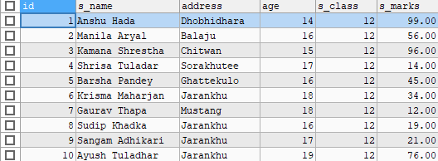

- CREATE TABLE EMPLOYEE (
id INT(3) PRIMARY KEY,
ename VARCHAR(30),
address VARCHAR(50),
ephone varchar(10),
ecity VARCHAR(30),
age INT(3),
edetails VARCHAR(255),
esalary INT,
epost VARCHAR(30)
);
- INSERT INTO EMPLOYEE VALUES
(1, 'Rohit Sharma', 'Thamel-10', 9812345611, 'Kathmandu', 29, 'Excellent team player', 120000, 'CEO'),
(2, 'Sita Gurung', 'Lalitpur-5', 9812345612, 'Lalitpur', 26, 'Very dedicated', 35000, 'Manager'),
(3, 'Arjun Khatri', 'Baneshwor-7', 9812345613, 'Bhaktapur', 32, 'Always learning', 45000, 'Clerk'),
(4, 'Maya Thapa', 'Kalanki-3', 9812345614, 'Pokhara', 28, 'Focused and organized', 30000, 'Manager'),
(5, 'Ramesh Shrestha', 'Putalisadak-9', 9812345615, 'Dharan', 30, 'Strong work ethic', 25000, 'Security'),
(6, 'Anita Tuladhar', 'Kirtipur-4', 9812345616, 'Itahari', 27, 'Attention to detail', 40000, 'Cleaning staff'),
(7, 'Suman Maharjan', 'Gausala-6', 9812345617, 'Dharan', 33, 'Highly experienced', 50000, 'Manager'),
(8, 'Nisha Khadka', 'Maitidevi-5', 9812345618, 'Hetauda', 31, 'Positive attitude', 30000, 'CEO'),
(9, 'Pratik Tuladhar', 'Balkot-8', 9812345619, 'Nepalgunj', 29, 'Step by step improvement', 35000, 'Clerk'),
(10, 'Kamal Adhikari', 'Sankhamul-12', 9812345620, 'Butwal', 24, 'Consistent performer', 28000, 'Security Guard');

- To display records using Join
SELECT s.s_name, s.age, e.address, e.ephone, e.epost
FROM student AS s
INNER JOIN EMPLOYEE AS e ON s.s_name = e.ename;
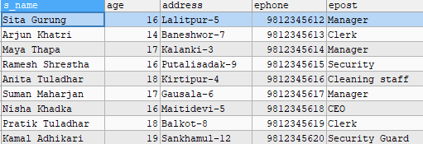

- To display records using left outer join.
SELECT s.s_name, s.age, s.s_marks, e.ephone, e.edetails
FROM student AS s
LEFT OUTER JOIN EMPLOYEE AS e ON s.s_name = e.ename;
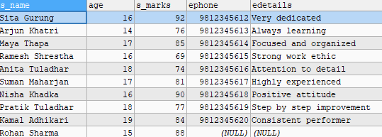

- To display records using right outer join.
SELECT s.s_name, s.age, s.s_marks, e.ephone
FROM student AS s
RIGHT OUTER JOIN EMPLOYEE AS e ON s.s_name = e.ename;
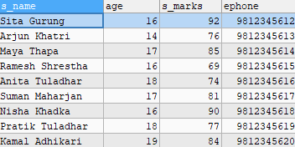

- To display records using full outer join
SELECT s.s_name, s.age, s.s_marks, e.edetails
FROM student AS s
LEFT JOIN EMPLOYEE AS e ON s.s_name = e.ename
UNION
SELECT s.s_name, s.age, s.s_marks, e.edetails
FROM student AS s
RIGHT JOIN EMPLOYEE AS e ON s.s_name = e.ename;

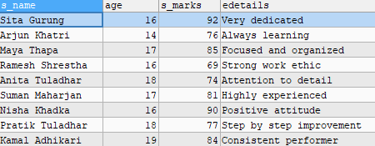

LAB 8: Write SQL code to display records using cross, equi and self join.
SQL Queries:
- CREATE DATABASE shopDB2;
- USE shopDB2;
- CREATE TABLE Products (
product_id INT PRIMARY KEY,
product_name VARCHAR(50),
category VARCHAR(30),
price DECIMAL(10,2),
stock INT
);

- CREATE TABLE Sales (
sale_id INT PRIMARY KEY,
product_id INT,
quantity INT,
sale_date DATE,
FOREIGN KEY (product_id) REFERENCES Products(product_id)
);

- INSERT INTO Products VALUES
(101, 'Laptop', 'Electronics', 75000.00, 20),
(102, 'Mobile Phone', 'Electronics', 25000.00, 50),
(103, 'Headphones', 'Accessories', 3000.00, 100),
(104, 'Chair', 'Furniture', 4500.00, 40),
(105, 'Table', 'Furniture', 8000.00, 25);

- INSERT INTO Sales VALUES
(1, 101, 2, '2025-09-01'),
(2, 102, 3, '2025-09-02'),
(3, 103, 5, '2025-09-02'),
(4, 101, 1, '2025-09-03'),
(5, 104, 2, '2025-09-03'),
(6, 105, 1, '2025-09-04');

- SELECT p.product_id, p.product_name, s.sale_id, s.quantity
FROM Products p
CROSS JOIN Sales s;
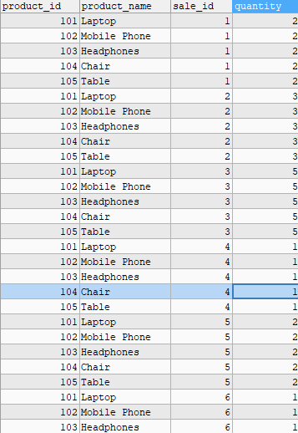

- SELECT p.product_id, p.product_name, s.sale_id, s.quantity, s.sale_date
FROM Products p, Sales s
WHERE p.product_id = s.product_id;
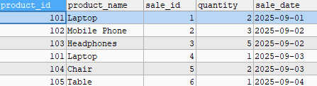

- SELECT p1.product_name AS Product1, p2.product_name AS Product2,
p1.price AS Price1, p2.price AS Price2
FROM Products p1
JOIN Products p2
ON p1.price < p2.price
ORDER BY p1.product_name;
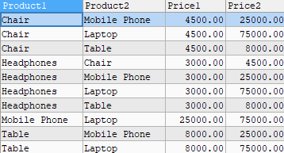

Lab 9:
Create table student with suitable attributes and insert 10-15 records and perform the matching operation using LIKE keywords and use all given char functions (substring, concat, length, upper, lower, trim, ltrim, rtrim, char, ascii).
SQL Queries:
- CREATE DATABASE lab9DB;
- USE lab9DB;
- CREATE TABLE Student (
id INT PRIMARY KEY,
s_name VARCHAR(50),
address VARCHAR(50),
age INT,
s_class INT,
email VARCHAR(50)
);
- INSERT INTO Student VALUES
(1, 'Rohan Sharma', 'Thamel', 15, 10, 'rohan@gmail.com'),
(2, 'Sita Gurung', 'Lalitpur', 16, 11, 'sita123@yahoo.com'),
(3, 'Arjun Khatri', 'Baneshwor', 14, 9, 'arjun.khatri@gmail.com'),
(4, 'Maya Thapa', 'Kalanki', 17, 12, 'maya.t@gmail.com'),
(5, 'Ramesh Shrestha', 'Putalisadak', 16, 11, 'ramesh.s@hotmail.com'),
(6, 'Anita Tuladhar', 'Kirtipur', 18, 12, 'anita_tuladhar@gmail.com'),
(7, 'Suman Maharjan', 'Gausala', 17, 10, 'suman@yahoo.com'),
(8, 'Nisha Khadka', 'Maitidevi', 16, 11, 'nisha.khadka@gmail.com'),
(9, 'Pratik Tuladhar', 'Balkot', 18, 12, 'pratik123@gmail.com'),
(10, 'Kamal Adhikari', 'Sankhamul', 19, 12, 'kamal_adhikari@yahoo.com'),
(11, 'Bibek Shrestha', 'Koteshwor', 15, 9, 'bibeksh@gmail.com'),
(12, 'Sarita Basnet', 'Chabahil', 17, 11, 'sarita.basnet@gmail.com');
- SELECT * FROM Student
WHERE s_name LIKE 'S%';
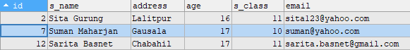

- SELECT * FROM Student
WHERE s_name LIKE '%a';
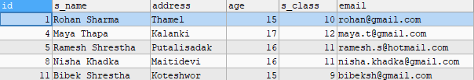

- SELECT * FROM Student
WHERE email LIKE '%gmail%';
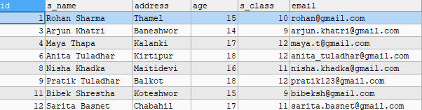
- SELECT * FROM Student
WHERE s_name LIKE '_a%';
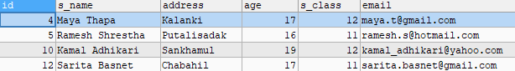

- SELECT s_name, SUBSTRING(s_name, 1, 5) AS short_name
FROM Student;
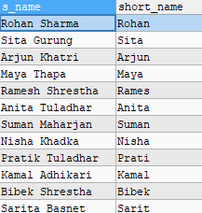

- SELECT CONCAT(s_name, ' - ', email) AS NameEmail
FROM Student;
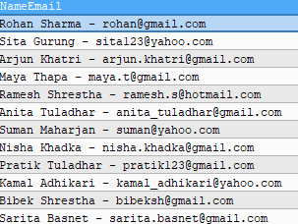

- SELECT s_name, LENGTH(s_name) AS name_length
FROM Student;
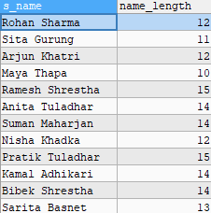

- SELECT UPPER(s_name) AS upper_name
FROM Student;
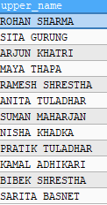

- SELECT LOWER(s_name) AS lower_name
FROM Student;
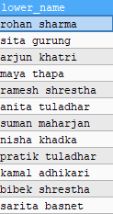

- SELECT TRIM(' test@email.com ') AS trimmed_email;
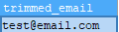

- SELECT LTRIM(' hello') AS left_trimmed;

- SELECT RTRIM('hello ') AS right_trimmed;
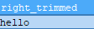

- SELECT CHAR(65) AS char_A, CHAR(97) AS char_a;

- SELECT s_name, ASCII(s_name) AS ascii_value
FROM Student;

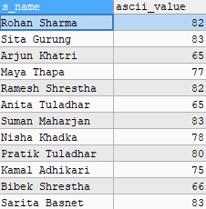

Lab 10:
Create table sales and products using key constraints (primary and foreign key), insert suitable data and perform DML operation (select clause, where clause and aggregate functions).

SQL Queries:
- CREATE DATABASE shopDB;
- USE shopDB;

- CREATE TABLE Products (
product_id INT PRIMARY KEY,
product_name VARCHAR(50),
category VARCHAR(30),
price DECIMAL(10,2),
stock INT
);

- CREATE TABLE Sales (
sale_id INT PRIMARY KEY,
product_id INT,
quantity INT,
sale_date DATE,
FOREIGN KEY (product_id) REFERENCES Products(product_id)
);

- INSERT INTO Products VALUES
(101, 'Laptop', 'Electronics', 75000.00, 20),
(102, 'Mobile Phone', 'Electronics', 25000.00, 50),
(103, 'Headphones', 'Accessories', 3000.00, 100),
(104, 'Chair', 'Furniture', 4500.00, 40),
(105, 'Table', 'Furniture', 8000.00, 25);

- INSERT INTO Sales VALUES
(1, 101, 2, '2025-09-01'),
(2, 102, 3, '2025-09-02'),
(3, 103, 5, '2025-09-02'),
(4, 101, 1, '2025-09-03'),
(5, 104, 2, '2025-09-03'),
(6, 105, 1, '2025-09-04');
- SELECT * FROM Products;
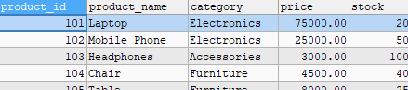

- SELECT s.sale_id, p.product_name, s.quantity, p.price, (s.quantity * p.price) AS total_price, s.sale_date
FROM Sales s
INNER JOIN Products p ON s.product_id = p.product_id;
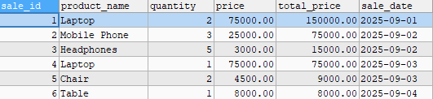

- SELECT product_name, price
FROM Products
WHERE price > 10000;
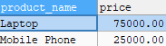

- SELECT SUM(s.quantity * p.price) AS total_sales
FROM Sales s
JOIN Products p ON s.product_id = p.product_id;

- SELECT AVG(price) AS avg_price FROM Products;
- SELECT p.product_name, COUNT(s.sale_id) AS total_sales_count, SUM(s.quantity) AS total_units_sold
FROM Products p
LEFT JOIN Sales s ON p.product_id = s.product_id
GROUP BY p.product_name;
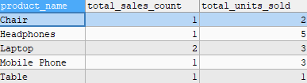

Lab 11:
- Write sql code to create alias name of existing attributes.
- Create table teacher with suitable fields
- Insert seven records.
- Give increment of 30% salary of computer department.
- Give increment of 50% of salary who works more than 10 years.
- Find the highest paying and lowest paying teacher from math department
SQL Queries:
- CREATE DATABASE lab11DB;
- USE lab11DB;

-- (b) Create table teacher with suitable fields
- CREATE TABLE Teacher (
teacher_id INT PRIMARY KEY,
t_name VARCHAR(50),
department VARCHAR(30),
salary DECIMAL(10,2),
experience INT
);

- INSERT INTO Teacher VALUES
(1, 'Ramesh Sharma', 'Computer', 50000, 8),
(2, 'Sita Gurung', 'Math', 45000, 12),
(3, 'Arjun Thapa', 'Computer', 60000, 15),
(4, 'Maya Koirala', 'Science', 40000, 7),
(5, 'Bikash Adhikari', 'Math', 55000, 9),
(6, 'Anita Shrestha', 'English', 47000, 11),
(7, 'Krishna Maharjan', 'Computer', 52000, 6);

- SELECT
t_name AS TeacherName,
department AS Dept,
salary AS MonthlySalary,
experience AS YearsOfExperience
FROM Teacher;
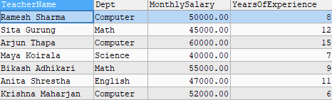

- UPDATE Teacher
SET salary = salary * 1.30
WHERE department = 'Computer';
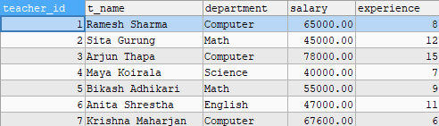

- UPDATE Teacher
SET salary = salary * 1.50
WHERE experience > 10;
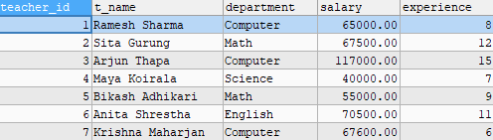

- SELECT t_name, salary
FROM Teacher
WHERE department = 'Math'
ORDER BY salary DESC
LIMIT 1;
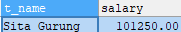

- SELECT t_name, salary
FROM Teacher
WHERE department = 'Math'
ORDER BY salary ASC
LIMIT 1;

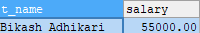

LAB 12:
1. Write SQL code to create view from Employee details table.
2. List data in view.
3. List data items using different operator.
4. Create view from multiple table and display data.
SQL Queries:
- CREATE DATABASE lab12DB;
- USE lab12DB;

- CREATE TABLE Employee (
emp_id INT PRIMARY KEY,
emp_name VARCHAR(50),
department VARCHAR(30),
salary DECIMAL(10,2),
age INT,
city VARCHAR(30)
);

- INSERT INTO Employee VALUES
(1, 'Ramesh Sharma', 'HR', 40000, 29, 'Kathmandu'),
(2, 'Sita Gurung', 'Computer', 60000, 32, 'Lalitpur'),
(3, 'Arjun Thapa', 'Finance', 50000, 28, 'Bhaktapur'),
(4, 'Maya Koirala', 'Computer', 70000, 35, 'Pokhara'),
(5, 'Anita Shrestha', 'Math', 55000, 31, 'Dharan');

- CREATE TABLE Department (
dept_id INT PRIMARY KEY,
dept_name VARCHAR(30),
location VARCHAR(30)
);

- INSERT INTO Department VALUES
(101, 'HR', 'Kathmandu'),
(102, 'Computer', 'Lalitpur'),
(103, 'Finance', 'Bhaktapur'),
(104, 'Math', 'Pokhara');

- CREATE VIEW emp_view AS
SELECT emp_id, emp_name, department, salary
FROM Employee;
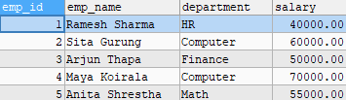

- SELECT * FROM emp_view;
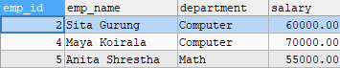

- SELECT * FROM emp_view
WHERE salary > 50000;
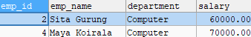

- SELECT * FROM emp_view
WHERE department = 'Computer';
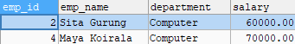

- SELECT * FROM emp_view
WHERE salary BETWEEN 40000 AND 60000;
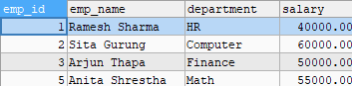

- SELECT * FROM emp_view
WHERE emp_name LIKE 'A%';
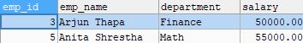

- SELECT * FROM emp_view
WHERE department <> 'HR';
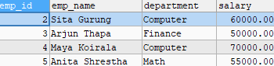

CREATE VIEW emp_dept_view AS
- SELECT e.emp_id, e.emp_name, e.department, d.location, e.salary
FROM Employee e
JOIN Department d ON e.department = d.dept_name;

- SELECT * FROM emp_dept_view;
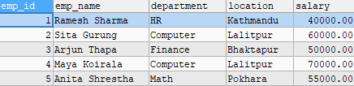

LAB 13:
1. Write SQL code to illustrate set comparison operation with sub-queries.
2. Write SQL code using EXIT keyword in select statement to test for empty relations.
SQL Queries:
- CREATE DATABASE lab13;
- USE lab13;

- CREATE TABLE Employees (
emp_id INT PRIMARY KEY,
NAME VARCHAR(100),
department VARCHAR(50),
salary INT
);

- CREATE TABLE Departments (
dept_id INT PRIMARY KEY,
dept_name VARCHAR(50)
);

- INSERT INTO Employees (emp_id, NAME, department, salary) VALUES
(1, 'Alisha', 'HR', 5000),
(2, 'Abilekh', 'IT', 6000),
(3, 'Barsha', 'HR', 5500),
(4, 'Diya', 'Finance', 7000),
(5, 'Ela', 'IT', 6200),
(6, 'Farsi', 'Marketing', 4800),
(7, 'Gaurav', 'Finance', 7100);

- INSERT INTO Departments (dept_id, dept_name) VALUES
(1, 'HR'),
(2, 'IT'),
(3, 'Finance'),
(4, 'Marketing'),
(5, 'Operations');

- SELECT NAME
FROM Employees
WHERE salary > ALL (
SELECT salary
FROM Employees
WHERE department = 'HR'
);
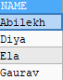

- SELECT NAME
FROM Employees
WHERE salary > ANY (
SELECT salary
FROM Employees
WHERE department = 'HR'
);
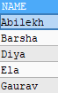

- SELECT NAME
FROM Employees
WHERE department IN (
SELECT department
FROM Employees
WHERE NAME = 'Alisha'
);
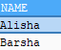

- SELECT dept_name
FROM Departments D
WHERE NOT EXISTS (
SELECT *
FROM Employees E
WHERE E.department = D.dept_name
);
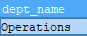

Lab 14:
1. Write SQL code to display records from one table that is not present in next table.
2. Write SQL code to determine 10th highest marks without using TOP/LIMIT keyword.
SQL Queries:
- CREATE DATABASE lab14;
- USE lab14;

- CREATE TABLE Student (
student_id INT PRIMARY KEY,
s_name VARCHAR(50),
marks INT
);

- CREATE TABLE ExamResults (
result_id INT PRIMARY KEY,
student_id INT,
marks INT
);

- INSERT INTO Student VALUES
(1, 'Rohan', 85),
(2, 'Sita', 92),
(3, 'Arjun', 76),
(4, 'Maya', 88),
(5, 'Bikash', 60),
(6, 'Anita', 95),
(7, 'Krishna', 78),
(8, 'Nisha', 90),
(9, 'Pratik', 82),
(10, 'Kamal', 87);

- INSERT INTO ExamResults VALUES
(101, 1, 85),
(102, 2, 92),
(103, 4, 88),
(104, 5, 60),
(105, 6, 95),
(106, 8, 90),
(107, 9, 82);

- SELECT *
FROM Student S
WHERE NOT EXISTS (
SELECT *
FROM ExamResults E
WHERE S.student_id = E.student_id
);
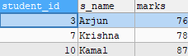

- SELECT MIN(marks) AS tenth_highest
FROM Student
WHERE marks >= ALL (
SELECT marks
FROM Student
WHERE marks NOT IN (
SELECT DISTINCT marks
FROM Student AS S2
WHERE S2.marks > Student.marks
ORDER BY marks ASC
)
);

